

# 

COMPLAINT : 3

DATE: 18/Mar/2021

The Manager,

BANK AL-HABIB

ABC,LHR ZONE

Subject: Quotation of Repair and Maintenance. FOR APPROVAL

Number of AC: 1

|  |  |  |  |  |
| --- | --- | --- | --- | --- |
| Sr. | Job Description | Qty | Rate | Amount |
|  | Gas Charging ( upto to 2 Ton) Inverter AC Unit Unit | 2rft | 4670.0 | 9340.0 |
|  | Total |  |  | 9340.0 |
|  | Tax 16% |  |  | 1494.4 |
|  | Visit Charges | 2 | 780 | 1560 |
|  | Total |  |  | 12394.4 |

**Yours truly,**

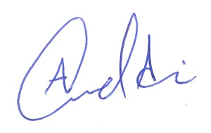 **ECO ENTERPRISES**